Notice of Public Meeting
HUMBOLDT DEVELOPMENT AUTHORITY
January 17, 2018, 4:00 PM
Winnemucca City Hall, 90 W. 4th St., Winnemucca, NV
All times on this agenda are approximate. Consideration of items may require more or less time than is scheduled. Items on the agenda may be taken out of order; the public body may combine two or more agenda items for consideration; and the public body may remove an item from the agenda or delay discussion relating to an item on the agenda at any time. Public comment is designated for discussion only. The public has the opportunity to address the Board on any matter not appearing on the agenda; however, no action may be taken on a matter raised until the matter itself has been specifically included on the agenda as an item upon which action may be taken. Additionally, public comment may be heard on any item listed on the agenda. Persons are invited to submit comments in writing and/or attend and make comments on an agenda item at the Board meeting. All public comment may be limited to three (3) minutes per person, at the discretion of the Board.

HDA Agenda – January 17, 2018

- 4:00 PM - Call to Order/Pledge of Allegiance
- Public Comments: General public comment is designated for discussion only. The public has the opportunity to address the Board on any matter not appearing on this agenda; however, no action may be taken on a matter raised until the matter itself has been specifically included on the agenda as an item upon which action may be taken.
- Approval/Amendment of the December 20, 2017 meeting minutes - Discussion and Action.
- Review and Approve Bills & Invoices, if any – Discussion and Action
Don Vetter: $500.00- Continuing media preparation/Winnemucca Futures
- Update and information regarding the redesigned HDA website and related matters.
- Discussion and possible action for the “Explore Your Future” event to be held in spring, 2018 and other related issues.
- Discussion and possible action regarding the Winnemucca Futures event to be held in January 18, 2018, including the final, schedule, speakers, sponsors, and other related issues.
- Board Member Comments and Reports - Discussion Only
- Staff Report on activities, current NNRDA leads, general update – Discussion Only, Jan Morrison
- Public Comments: Public comment is designated for discussion only. The public can address the Board on any matter not appearing on this agenda; however, no action may be taken on a matter raised until the matter itself has been specifically included on the agenda as an item upon which action may be taken.
- Adjournment
-
CERTIFICATE OF POSTING
PLACES POSTED: Humboldt County Courthouse: Rooms 201, 205 & 207: 50 W. 5th St.,
Humboldt County Library: 85 E. 5th St., Humboldt County Annex: 25 W 4th St., Winnemucca City Hall: 90 W. 4th St.
HDA website: http://hdanv.org “HDA Meeting Agendas” State of Nevada Public Notice website: https://notice.nv.gov/

MEETING DATE: January 17, 2018 POSTED: January 12, 2018

POSTED BY: 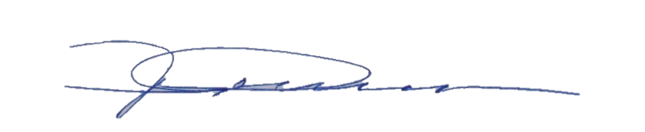

NOTICE TO PERSONS WITH DISABILITIES
Reasonable efforts will be made to assist and accommodate physically disabled persons verifying to attend the meeting. Please call Winnemucca City Hall at 623-6338 in advance so that arrangements may be conveniently made.
EQUAL OPPORTUNITY NOTICE
Humboldt County and the City of Winnemucca are Equal Opportunity Employers and will not discriminate against employees
or applicants for employment or services in an unlawful manner.

