Housing remains the hottest topic in economic development nationwide, statewide, and in Humboldt County, Nevada. With the price of lumber more than doubling in the past year, supply chain interruption for building components (hardware, adhesives, chemical treatments for lumber, etc.), and factory-built housing units (modular and manufactured) easily one year out, coupled with a healthy population increase, it is no wonder we are in a housing shortage.

However, Humboldt County, City of Winnemucca and this office started meeting three years ago to work on re-energizing housing construction in this area. We were spurred by a major employer survey that showed over a thousand new jobs formed in the next 5 years or less. Although some of those jobs have been filled, the current number remains at 1,000 or more with the advent of new developments such as Lithium Nevada and West Coast Salmon. Each of those high-paying jobs can generate at least one more secondary job in the community. Approximately .4 housing units will be needed for every new job. That translates into around 800 units. That number could be high or low. We will re-examine it in our Fall 2021 Housing Market Report.

Over the past 3 years the City/County/Economic Development team has worked in tandem to remove governmental impediments to development. Regional Planning, Building Departments, County Assessor and other departments have been strong partners is nurturing development in general, and residential specifically. This local governmental cooperation is a driving force behind our ability to respond to the needs of our current and future employers in providing housing for their workforces.

Current Housing Market (existing and new) for sale as of 05/01/21
2021 | May 1  Listings | May 1 Under Contract | Ave. days on Market to Contract
Humboldt Co | 13 * | 40 | 7
Pershing Co | 9 | 11 | 23
Lander Co | 11 | 17 | 31
Churchill Co | 23 | 84
Fernley | 20 | 108
Reno/Sparks | 480 | 1,408
* In past years, homes on the market averaged around 125
New Frontier: residential lots by Boys & Girls Club of Winnemucca.

We included neighboring counties as their numbers reflect that the housing issue affects rural communities and urban cities.

The average price of approximately 340 homes sold in Humboldt County in 2020 was $220,000, with quite a few ‘investor rehab’ homes snatched off the market in early 2020. Those types of homes don’t exist on the market any more. The average price of 75 homes sold 01/01 - 4/30/2021 increased to $286,000. (does not include 8 single-wide manufactured homes). Newly constructed homes are now generally priced from the mid $300,000s to well over $450,000.

With the average days on the market at 7, it is easy to see that many buyers are left out of the current market. The number of housing sales per month are decreasing due only to the limited supply. Prices are climbing and sellers receive multiple bids. We feel monthly sales could easily be in the 40-50 homes per month with increased inventory.
Past Housing Production
Residential Building permits
 | 2021 thru 4/30 | 2020 | 2019 | 2018 | 2017
# SFD | 13 | 6 | 6 | 4 | 9
$ SFD | 2,770,318 | 950,018 | 976,668 | 701,675 | 1,241,279
# Man.  Home | 15 | 40 | 46 | 22 | 19

Current Housing Production
The residential building permit chart shows permits issued the first 3 months of this year are more than double the previous 12-month period. Builders are on track to continue and accelerate this trajectory. The following housing developments are currently underway. Please keep in mind that although brokerages are listed for each development, a buyer is free to use their own agent to view and purchase these homes:

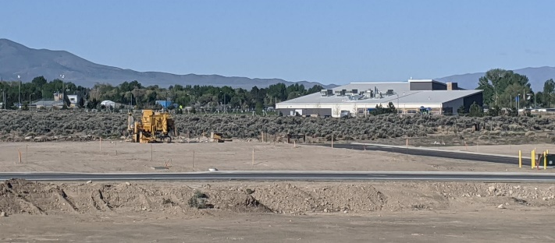
- Western States Investments: Sixteen homes next to Grass Valley Elementary School. 1,500 – 1,900 sf, 3 car garages, landscaping & fenced. $260,000-$340,000 NOTE: All sold or under contract as of 5/1/21.
www.nv-remax.com/

- New Frontier Village: Across from the Boys & Girls Club. Phase I (7 of 25 homes) coming mid-July. 1,600 – 1,800+ sf, 2 car garages, landscaping, fencing. Starting around $369,000. www.century21sonomarealty.com/

- Off U.S. 95 at Lonnie Lane. June construction start. Six homes 1,600 – 1,800 sf, 2 car garages, landscaped & fenced. Starting around $370,000. www.nv-remax.com/

- Six homes on Crown Royal Circle off Grass Valley Road. 1,500 – 1,600 sf. Fenced with off-street parking and front landscaping. Starting late May, priced at $225,000 & up. www.nv-remax.com/

- Carriage Court Manufactured Home Community. Hanson Street and West McArthur Avenue. 14 new homes for sale projected for August. Six 3 bedroom/2 bath and eight 2 bedroom/2 bath homes starting in the low $80s. Rented space. www.carriagecourtmhc.com/ 775-403-5363.
Note that contrary to some outmoded notions, the resale prices of manufactured homes in our rental parks tend to appreciate.

- Humboldt Homes by Braemar. Executive style homes in a 26 lot development, with 4 slated for development in 2021. Located on Marla Drive off Great Basin Avenue. Homes range from 1,300 to 2,100sf with 3 car garages. Prices start at $380,000. www.homesbybraemar.com.

- At least two additional developments are slated to start mid to late summer:
- High end homes along Mesa Way behind Humboldt Museum off U.S. 95. These will start at 1,800sf and be priced in the low $400,000s. www.century21sonomarealty.com
- Eight homes on large 1.25 acre lots will go in the Grass Valley Road and Grass Valley Elementary school area. www.nv-remax.com.

An informal survey of local builders/developers’ projects shows at least 120 new homes will be constructed in 2022. That is great news, but not enough. We are looking forward to an acceleration of new construction as current developers gain momentum and new builders join the market. Apartments can help ease the housing market, and vacancies are snapped up as soon as they come on the market. We are optimistic that new apartment developments will be announced this year.

It should be noted that over 1,500 residential lots (single and multi-family) are in various stages of entitlements in the Winnemucca area. Some were filed as long as 10 years ago. Even if some of the entitlements have lapsed, in most cases they can quickly be revived. Our approval process is measured in a few months, not years. A quick search on Loopnet.com, Realtor.com or better yet, local real estate offices, will produce current information.

Factory Built Homes for property owners and developers
Manufactured and Modular homes have been a staple for home development in our area, particularly for individuals who own their own property. Offering quality construction that can be customized, they have helped in a market with limited workforce availability and are always in demand. Resale values tend to be the same as traditional stick-built homes. However, due to Covid -19 disruption in the supply chain, delivery can be up to 10 months out. This will shorten as factories get caught up. These dealers are located in Winnemucca:

Solid Gold Homes www.solidgoldhomes.com
Craftsman Homes www.forahouse.com
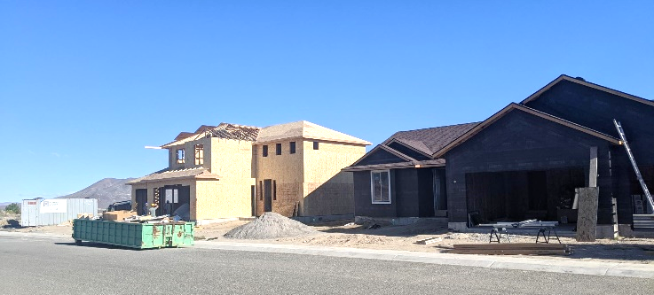
Affordable Home Center: www.ahcnv.com

Apartments – NEEDED !!!
Apartments remain to be an elusive housing target. Our employee numbers, wages, high rents, and nearly 0 vacancy rate supports apartment development. But rural communities are non-traditional places to build and more importantly, to attract major financing. A Nevada Rural Housing Authority 2014 study stated 120-150 new rental units would be needed by the end of 2020. Only one 32-unit complex has been built (2015), That study did not anticipate Lithium Nevada and West Coast Salmon projects.
Humboldt Homes: Marla Drive & Great Basin Ave. www.homesbybraemar.com
Because most housing studies and statistics tend to use old data, assumptions, and broad stroke formulas in rural areas, accurate data on Humboldt County housing is pretty much non-existent.

►►►However, the Humboldt Development Authority has commissioned a study from UNR to provide accurate and relevant data for housing (single family & multi-family) developers and builders. Humboldt County Assessor Andy Heiser is working with the researcher to insure accuracy. That study, which will include population counts, will be available in June and can be obtained by sending a request to jan.morrison@humboldtcountynv.gov.

Short Term Housing
RV Parks, Extended Stay motels, and motels in general also serve as housing stock. New workers transferring into our area may stay in temporary housing for months as they search for permanent housing. Often their employers subsidize this cost. Optimally though, we want to welcome them and their families into our community as permanent residents.

Because of the need for short term housing for new employees, but also for the huge number of contractors who will be employed at the upcoming large projects, we keep a list of short-term housing. Request it by emailing: jan.morrison@humboldtcountynv.gov. Most real estates offices also handle homes and apartments for rent or lease, so it is beneficial to call them. A quick internet search for Winnemucca Real Estate offices will bring them up.

Workforce
Manpower’s area manager, Amby Bixby, reports that in Northern Nevada, Manpower has seen job growth in minor mining companies, construction companies and youth care settings. Pay has jumped about 16% across the board. Current job openings range from county & government jobs, entry level mining, construction and farm workers, truck drivers and maintenance personnel. Good jobs are available in every community.
A year ago, at the onset of Covid 19, a group met to discuss the lack of trades and craft training in rural communities. They felt courses promoted by the Nevada Builders Alliance could be the answer. Obtaining a grant from the Desert Research Institute, instruction through Great Basin College, and donations from local businesses, they launched the BuildNV program offering 80-hour NCCER (nccer.org) certified building maintenance and construction. Five classes have been completed, giving students a leg-up towards great jobs in the construction industry. More information is found at: https://www.gbcnv.edu/cte/build_nv.html
►►►Don’t forget to ask for a copy of the UNR study on Humboldt County housing! Jan.morrison@humboldtcoutynv.gov

